6. Evaluation
6.1 Evaluation Methodology
After training the Convolutional Neural Network (CNN) for plant disease classification, the model was evaluated using a separate test dataset (test_ds) that was not seen during training. The evaluation process was designed to assess the model’s generalization ability on unseen images.
To ensure stable execution, the model was trained using GPU acceleration, while all evaluation metrics and visualizations were generated using CPU-based execution. This approach avoids hardware-specific limitations and ensures reproducible results.
The following evaluation techniques were used:
- Accuracy and loss curves
- Test dataset accuracy and loss
- Confusion matrix
- Classification report (Precision, Recall, F1-score)

6.2 Accuracy and Loss Curves
The accuracy and loss curves were plotted using the training history obtained during model training.
- Training Accuracy represents how well the model learned patterns from the training data.
- Validation Accuracy indicates the model’s performance on unseen validation data.
- Training Loss shows the error during training.
- Validation Loss reflects how well the model generalizes.
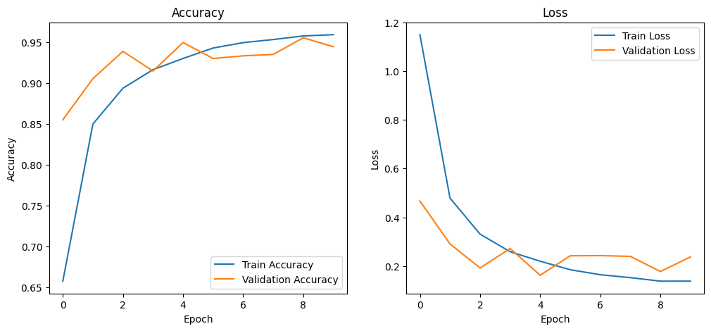
Observations
- Training and validation accuracy increased steadily with each epoch.
- Validation loss followed a decreasing trend similar to training loss.
- No significant gap between training and validation curves was observed, indicating minimal overfitting.
- The model demonstrated stable learning behaviour across epochs.

6.3 Test Dataset Evaluation
The trained model was evaluated on the test dataset to measure real-world performance.
- Test Accuracy reflects the overall correctness of predictions on unseen data.
- Test Loss measures the prediction error on the test dataset.
The evaluation confirmed that the model generalizes well to new plant leaf images and maintains consistent performance beyond the training data.
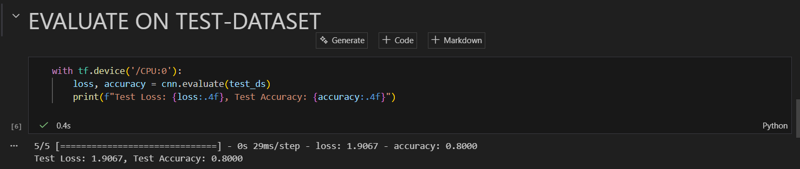

6.4 Confusion Matrix Analysis
A confusion matrix was generated using the test dataset to analyze class-wise performance.
The confusion matrix provides:
- Correct predictions along the diagonal
- Misclassifications in off-diagonal cells
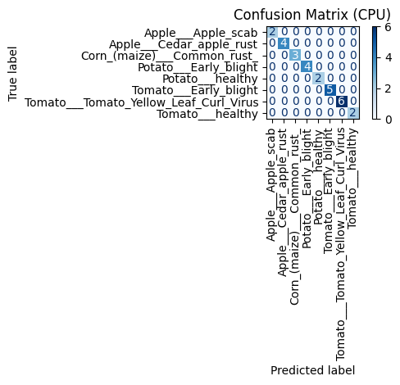
Observations
- Most classes showed strong diagonal dominance, indicating high correct classification rates.
- A small number of misclassifications occurred between visually similar plant diseases.
- The confusion matrix highlights the robustness of the model across multiple plant disease categories.
This analysis helps identify specific classes where further data augmentation or model tuning may improve performance.

6.5 Classification Report
A classification report was generated to provide detailed performance metrics for each class.
The report includes:
- Precision: Accuracy of positive predictions
- Recall: Ability to correctly identify actual positives
- F1-score: Harmonic mean of precision and recall
- Support: Number of test samples per class
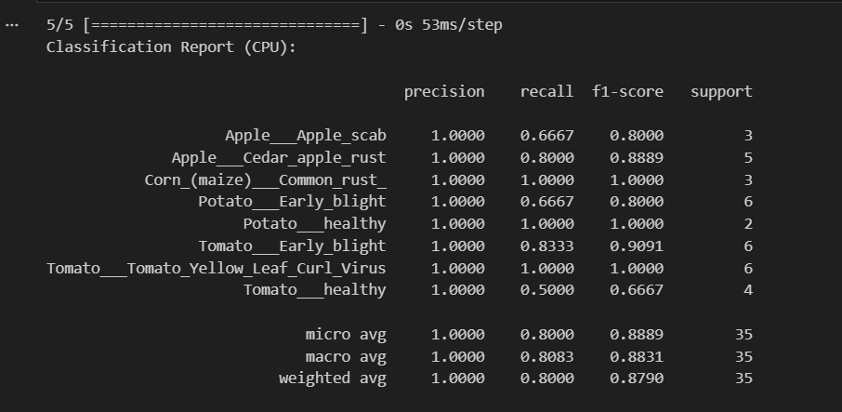
Observations
- Most classes achieved high precision and recall values.
- Balanced F1-scores indicate consistent performance across categories.
- Classes with fewer samples showed slightly lower scores, which is expected in multi-class datasets.
Overall, the classification report confirms that the model performs reliably across different plant disease classes.

6.6 Summary of Evaluation
- The CNN model demonstrated strong classification performance on unseen test data.
- Accuracy and loss curves indicated stable learning with minimal overfitting.
- Confusion matrix and classification report confirmed robust class-wise predictions.
- The evaluation validates the effectiveness of the proposed plant disease prediction system.

